DSI lecture 29 visualization 4

Learning objectives
- Discuss real world impacts of inaccessible data visualization
- Explore practical tips and resouruces used to improve the accessibility of our data visualizations relating to:
  - Colour
  - Text
  - Image descriptions
  - Getting out visualizations to the intended audiences
Case study: who gets to use data visualizations?
- 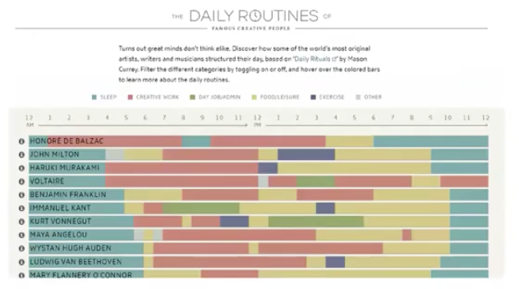
  - The dail routines plot is often used as an example of good data visualizations
    - Its good because it includes its data source (substantive qualities), uses an appropriate plot type for comparison (perceptual qualities) and limits its colour scheme (aesthetics)
- Questioning assumption
  - Sarah L fossheim a developer and designer was curious how the visualization would be perceived by color blind people and created 2 alternative versions based on what they’d look to people with different types of color blindness
    - Now we see the color labels are much less accessible
- 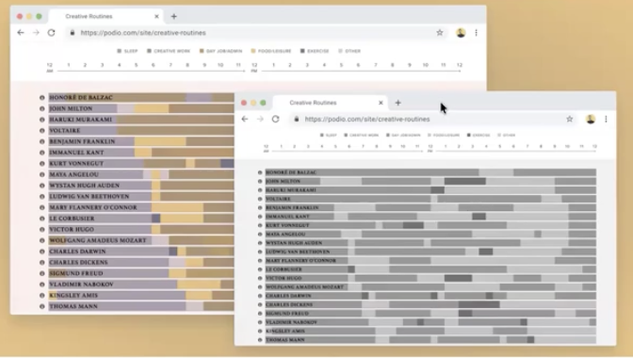
  - Therefore this data visualization isn’t accessible to people with color blindness
    - In this case the graph isn’t that important but what if it is really important data, for example something that could impact peoples lives and wellbeing
- 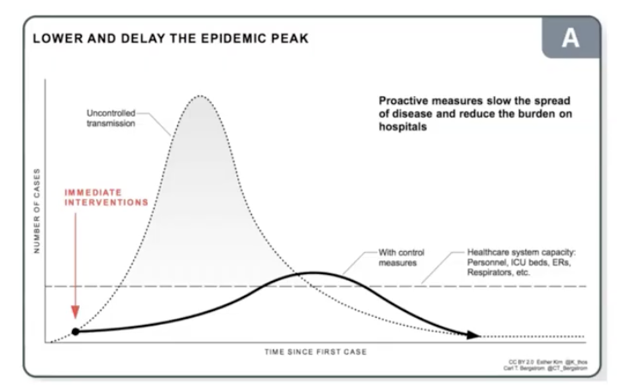
  - Main message of the second example is that proactive measures are really good at slowing the spread of diseases and reducing burden on the hospitals
    - Problems with the graph:
      - Red won’t stand out to people with red color blindness
      - No numbers on either axis
      - Grey shadow is very subtle with no clear reason for why its necessary
  - The graphic and spatial visualization of pandemic data are everywhere but most images are inaccessible to people with visual impairments
    - Lack of alternative descriptive text means people using screens cannot access the data
    - Tactile or braille versions of covid-19 data visualizations are rare and expensive to create
      - For readers with visual disabilities, inaccessible visualizations are at best demeaning and at worst damaging to health
- Failing to consider best practices for accessible design means our data visualization won’t have the desired positive effect on our audience and may even be harmful by excluding them
  - As professionals and academics who went to communicate our data visually we have a responsibility to prioritize accessibility
Government of Canada principles for accessible design
- The govy lays out for broad goals for accessible design
  - Make info clear, concise and easy to use
  - Present information in predictable barrier-free ways
  - Provide barrier-free ways for people to interact with you
  - Make sure technology-based products work with assistive technologies and devices\
How do we incorporate these accessibility goals into our data visualization practices?
- Colour
  - Colour is one of the most useful features of many data visualizations and we have to be aware of how it can be perceived differently by our audience
    - Think of color in terms of 3 channels
      - Magnitude of these 2 channels is suitable for ordered data:
        - Luminance: how bright/dark the color is
        - Saturation: how colorful (e.g. different saturations of red for how hot temperature is)
      - Hur is an identity channel suitable for categorical data
        - Hue: pure colors
    - 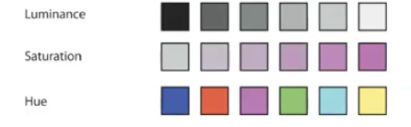
  - We adopt this principle is that luminance and saturation are naturally perceived as ordered, whereas hue is not
    - Aligns with reducing cognitive load by controlling these 2 colors
- Mark size + colour
  - Small objects with colour should have more saturation
    - It’s a lot easier to distinguish larger areas apart even if they have similar colors (see below)
    - 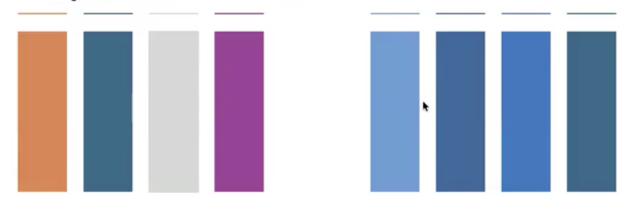
- Brightness and contrast
  - Overly bright colours can be painful to look at and overwhelming for people with sensory issues and on the autism spectrum
  - Contrast is the ratio between brightness of 2 different colors
    - We want to strive for a higher contrast to make it easier to tell colours apart
- 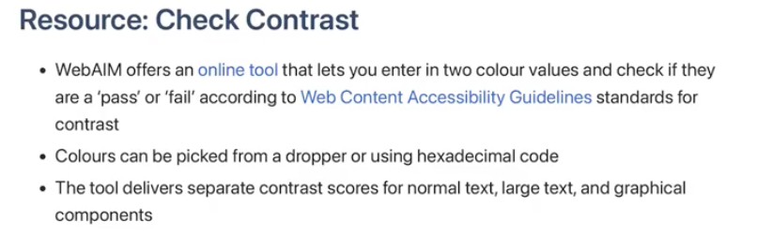
- 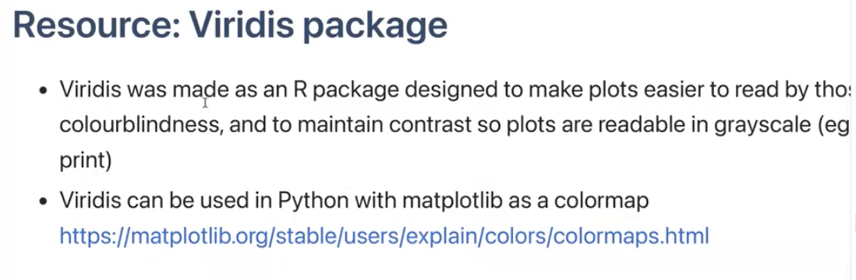
- 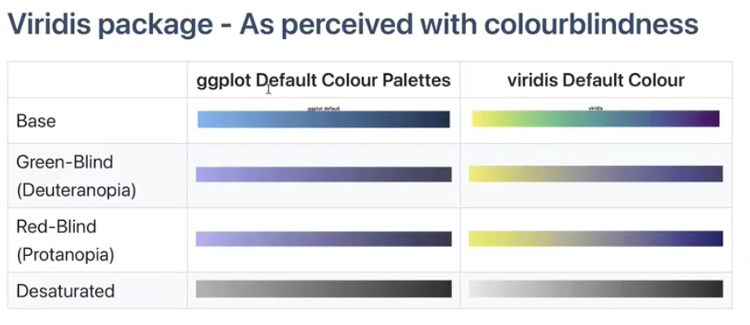
Moving beyond color
- Even when we make use of best practice for accessible use of colour in our data visualization we should avoid relying on colour when possible
Text
- Text is just as important as colour
  - If we want to minimize colours and patterns, data labels can make visualizations easier to follow
  - Every visual element on our graph should be clearly described in the legend, including color which can reduce anxiety for our audience
Fonts and typefaces
- A typeface is a set of text characters (e.g. arial, timesnew roman)
- A font is a subset of a type face 9e.g. 12 pint arial)
  - Certain typefaces and fonts are considered more accessible than others
Typeface
- There is no single right typeface/font but generally sans-serif font are more accessible with cognitive disability
  - Typefaces identified as easier to read for people with dyslexia include:
    - Helvetica, courier, arial, verdana
  - We should also avoid overwhelming users by switching between many type faces in one graphic
Font size and spacing
- Text should be font size 12 or greater if possible
- Spacing between text also can effect its readiblility
  - For example monospaced text (each character takes same space) is more accessible than proportionally spaced text (each character takes the space it needs)
Describing data visualizations
- Alt-text
  - To ensure our data visualizations are accessible to people using a screen reading or unable to see the image include alternate text
    - This is a blurb with all essential info conveyed by the image
  - Generally alt-text consists of a description of the image; if there is text in the image alt-text should include the text
  - Alt-text should be in plain language and simple sentences when possible
- The most appropaite alt-text depends on the purpose of the image or visualization
  - If its only for decoration we can say smt small
  - If the focus is on specific individual mention name
  - If the focus is on the actual events or contents of an image discuss in detail
- Accessibility describing data-centric images for alt-text and figure captions requires additional considerations compared to descriing photos such as the previous example
  - In a paper people collected descriptions of sample data visualizations from graduate students and found that the descriptions could be grouped into 4 categories with increasing levels of details:
    - 1: focus on chart elements, like chart type, title, axis ranges, labels, colours
    - 2: description stats (mean), outliers, max and min points, correlations and comparing points
    - 3: complex trends, pattern synthesis, clusters, execeptions, common concepts
      - E.g. perceptual interpreations of the data
    - 4: context and domain insgihts, social and political context and explanations
      - E.g. subjective interpreations that go beyond the data
- Alt-text for graphs and plots of data
  - The 4 types of descriptive text are not equally helpful
    - Level 4 on its own was the least useful to blind participants
      - Blind participants preferred descriptions to contain facts about the data letting them interpret it themselves
    - Level 1 was least helpful
  - 40% of blinf participants thought the most useful descriptions combined content from multiple levels (e.g. 2-3)
Can people actually access our data visualizations
- Cross-browser functionality
  - If our data visualization is going to be embedded in a web page or accessible online we need to check its visible in
    - Chrome
    - Firefox
    - Internet explorer
    - Safari
  - This is especially important in some professional contexts were browser use may be limited/regulated
- Cost and accessibility
  - If our data visualization is intended to reah the public of a subgroup of the public the cost of accessing our visualization is an accessibility issue
    - E.g. most academic publications require a subscription
  - To maximize accessibility of our data products we can consider
    - Open access (data for free online)
    - Creative commons license (simple license to facilitate sharing and reuse of work)
  - When in doubt about accessibility of our data visualizations show someone!
    - User testing and feedback is the best way to understand accessibility for our intended audiences
- 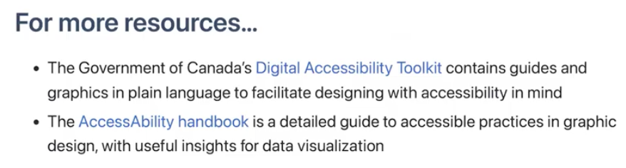
Coding overview
- Learn about subplot notation in matplotlib
- Put multiple visualization on the same axes objects
- Show errors
- Adjust figure layout
- Add images to plots
Subplots
- Recall:
  - A figure is a container holding a set of aces
  - The axes is our actual plot/graph
  - A figure can hold multiple axes
  - Every visual element is called an artist and belongs to an axis
- Introducing subplots
  - In past lessons we learned to define our figures and its one axis using
    - Fig. ax = plt.subplots(figsize=(5, 3))
  - Now we want to have 2 plots next to each other so we define multiple axes and their relative positions
    - E.g. fig, (ax1, ax2) = plt.subplots(ncols=2, nrows=1, figsize=(7,3))
  - Then we can apply different visualizations to each axis
      - ax1.scatter(x1, y1)
      - ax2.bar(x2, y2)
    - we can customize labels and everything else individually as well!
- We can also arrange the subplots within our figure by using plt.subplot_mosiac()
    - This function creates a visual layout of how we want our axes to be arranges, and the different visual layout is created and labelled via strings
E.g. fig, someaxes = plt.subplot_mosaic([['ax1', 'ax3'],
['ax2', 'ax3']],
figsize=(7, 4))
- Subplots without a grid arrangement - data
  - So similar to above we just call the graphs we want to make but we also specify the axes as a list after our overall axis name
    - Someaxes[‘ax1’].scatter(x1, y1)
Modifying figure layouts
- We can specify labels normally calling different subplots
  - E.g. someaxes[‘ax1’].set_xlabel(‘text’, fontsize=x)
- We can use layouts to make sure that our subplots fit neatly in our figure area
  - There are 2 main kinds of layout we consider:
    - Tight layout adjust subplots so tick labels, axis labels and titles don’t overlap or leave the figure area
    - Constrained layout works similarly accept it also fits things like legends or colorbars
- We add these by adding a layout = ‘x’ when we create the subplot
  - E.g. fig, someaxes = plt.subplot_mosaic([['ax1', 'ax3'],
  - ['ax2', 'ax3']],
  - figsize=(7, 4)
              - Layout = ‘constrained’)
  - *it will adjust plot sizes as necessary
Multiple visualizations on one axes
- Here we just call multiple plot methods on the same axis
  - Varibles must all be the same length
E.g. fig, ax = plt.subplots(figsize=(7, 3))
ax.bar(x, y1, color = 'indigo')
ax.plot(x, y2, color = 'red')
add error information
- First we need to calculate the standard deviation of our data,
- Then plot our data as before adding an error bar command
  - y2_sd = np.std(y2)
  - fig, ax = plt.subplots(figsize=(7,3))
  - ax.plot(x, y2, color ='red')
  - ax.errorbar(x, y2, yerr = y2_sd,
  - fmt = 'none',
  - ecolor = 'indigo',
  - elinewidth= 4,
  - capsize = 6,
  - capthick=4)
    - Fmt indicates the format of the datamarkers
      - E.g. to indicate a circle at the datapoint you would type o to represent a circle – for a line
    - Elinewidth defines line thickness
    - Capsize defines the size of the error bar cap
    - Capthick defines the thickness of the error bar cap
- If you don’t want to see error bars for every point you can specify intervals using errorevery = x
- ax.errorbar(x, y2, yerr = y2_sd,
- fmt = 'o-',
- ecolor = 'indigo',
- elinewidth= 4,
- capsize = 6,
- capthick=4,
- errorevery= 2)
  - This modifies for how many datapoints an error bar appears
Adding images to plots
- First we extract the image (see code)
- Then we make a plot
- Then we overlay a new axis using (this creates the box doesn’t add the image)
  - Variable_name = fig.add_axes([x, #x coords y, # y coords width, #image width height] #image height)
- Lastly we add the image to the plot using
  - Variable_name.imshow(image)
  - Variable_name.axis(‘off’)
    - This lets us remove the outline of the image
What if we want to add multiple images?
- Because all the coordinates are fractions relative to the whole figure, we just specify multiple boxes and add images again!
Saving our visualizations
- First we define where we want to save our visualization and the filename with
  - Path = ‘filepath’
  - Filename = ‘/file_name.png’
- Then save the visualization
  - Plt.savefig(path+filename, dpi = image_resultion)
Assignment 3 final project
- You can pick from 2 datasets of interest
  - Extract the dataset, then use python and one other data visualization software (r, excel etc) to create two distinct visualizations from you dataset of choice
  - For each visualization describe and justify:
    - What software you used
    - Your intended audience
    - What information/msg you are trying to convey with your visualization
    - What aspects of design did you consider when making the visualization? How did you apply them? With what elements of your plots?
    - How did you ensure your data visualizations are reproducible? If the tool you used to make your visualization is not reproducible how will this impact your visualization
    - How did you ensure your visualization is accessible
    - Who are the individuals/communities who might be impacted by your visualization
    - How did you choose which features of your choosen dataset to include or exclude from you visualization
    - What underwater labor contributed to your final data visualization product

